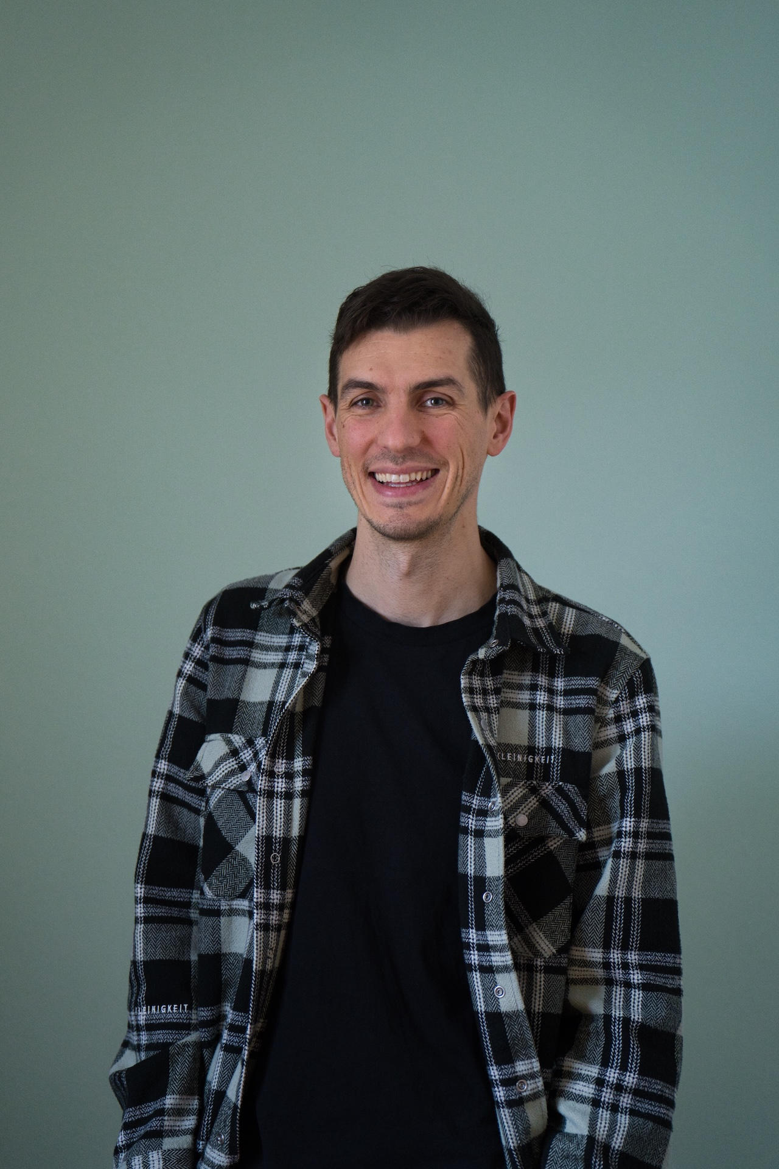
RAPHAEL SCHNAITL

DevOps Engineer / Cloud Architect

Schnaitl IT Solutions

 | raphael@schnaitl.tech
 | +49 8654 1280520

Skills

Cloud / Platforms
AWS | ◆◆◆◆◆
Azure | ◆◆◆◆◆
Kubernetes | ◆◆◆◆◇
Pipelines and Automation
Gitlab | ◆◆◆◆◆
Azure DevOps | ◆◆◆◆◆
Github | ◆◆◆◆◇
Jenkins | ◆◆◆◆◇
Tools
Terraform / OpenTofu | ◆◆◆◆◆
AWS CDK | ◆◆◆◆◆
Helm | ◆◆◆◆◆
ArgoCD | ◆◆◆◆◆
Packer | ◆◆◆◆◇
Ansible | ◆◆◆◆◇
Terragrunt | ◆◆◆◆◇
Programming
C# | ◆◆◆◆◆
TypeScript | ◆◆◆◆◇
Python | ◆◆◆◆◇
Shell | ◆◆◆◆◇
Java | ◆◆◆◇◇
Monitoring
Prometheus | ◆◆◆◆◆
CloudWatch | ◆◆◆◆◆
Grafana | ◆◆◆◆◇
DataDog | ◆◆◆◆◇
OS
Windows | ◆◆◆◆◇
Linux / Debian / Ubuntu / AmazonLinux | ◆◆◆◆◇

References

A collection of my past projects and experiences over the last 15 years.
Deloitte - Migration Manager |  | 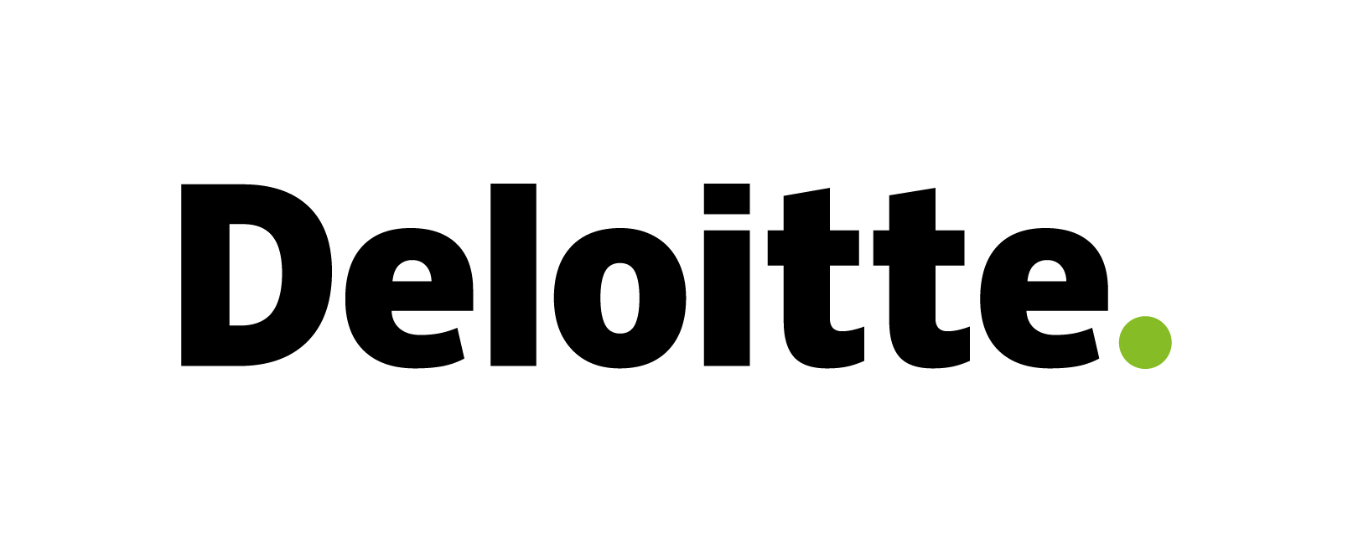
June 2025 - January 2026
Coordinate and plan the migration of applications as part of a large AWS infrastructure carveout project. Design solution architectures for migrating applications. Address technical blockers and manage impediments to enable migration teams to shift infrastructure. Report and support stakeholders throughout the complete process of planning, execution, and handover.
Tech Stack: | AWS, Terraform, IaC, Landing Zone, Dynatrace, JFrog, Jira, Confluence, Linux, Reporting

ventx GmbH - Cloud Architect / Head of Branch Office |  | 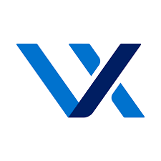
March 2019 - June 2025
My responsibilities encompassed a wide spectrum of tasks, including new client acquisition, project planning, migration management, and delivering final handovers with training sessions. Additionally, I was tasked with establishing ventx's second operational location in Austria, which involved recruiting, training, and developing a high-performing team of professionals, as well as managing and planning budgets for this expansion initiative.
Tech Stack: | AWS, Azure, Terraform, Gitlab, Redis, PostgreSQL, GraphQL

Finanz Informatik Technologie Service GmbH & Co. KG - Cloud Architect / DevOps Engineer |  | 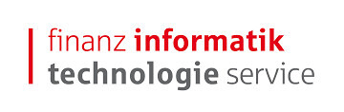
October 2024 - February 2025
Reviewed and optimized existing cloud architecture for improved efficiency. Implemented automated drift detection system for infrastructure consistency monitoring. Streamlined rollout pipelines and approval workflows for modules and deployments alike.
Tech Stack: | Azure, Azure Functions, Azure Container Service, Azure Container Registry, Azure DevOps, Terraform, Terratest, Azure Dashboard

DB Systel - Cloud Architect |  | 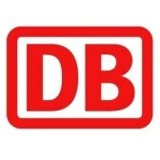
June 2024 - September 2024
Implemented centralised logging and audit system for enhanced operational visibility. Developed reusable infrastructure modules enabling efficient cloud resource deployment. Extended cloud architecture to support growing cloud adoption.
Tech Stack: | AWS, Ansible, Gitlab, Python, Shell, Terraform, Java, Graylog, Grafana, Fargate, Redis

Ratepay GmbH - Cloud Architect |  | 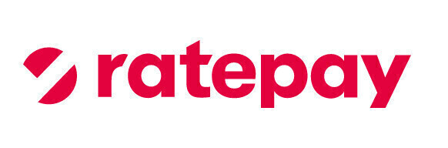
November 2023 - May 2024
Developed multi-account AWS organization structure with secure landing zone. Established centralised IAM and networking components for consistent security controls. Created reusable infrastructure modules to accelerate cloud migration. Implemented automated deployments for ECS and Fargate.
Tech Stack: | AWS, Terragrunt, Terraform, Jenkins, Bitbucket, ECS, Docker, Fargate, ALB, HA Proxy, Go

1NCE GmbH - Cloud Architect / DevOps Engineer |  | 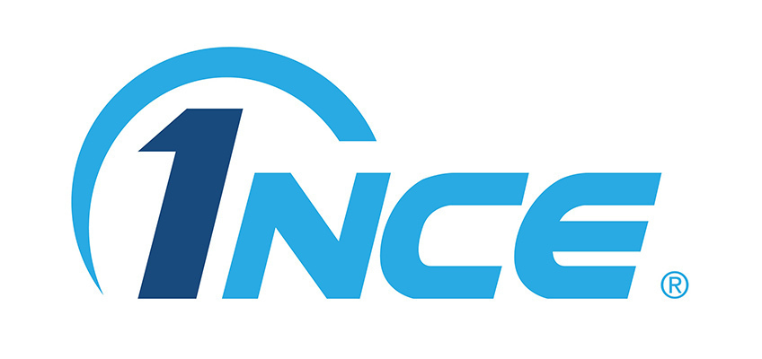
April 2022 - September 2023
Designed and implemented cloud-native architectures for a mobile network backend on AWS. Created Infrastructure as Code using Terraform for automated deployments. Established GitOps workflows with ArgoCD for Kubernetes deployments. Implemented monitoring and logging solutions using the ELK stack.
Tech Stack: | AWS, Terraform, Docker, Kubernetes, EKS, AWS CDK, Typescript, Packer, Python, Go, ArgoCD, Grafana, Prometheus, PromQL, Redis

Immowelt AG - Cloud Architect / Migration Lead |  | 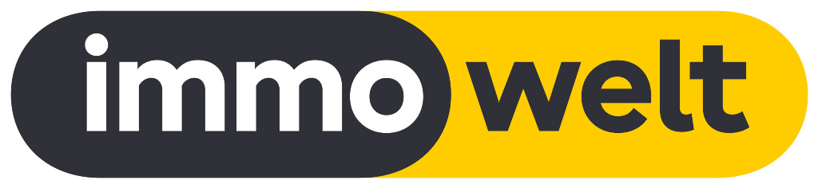
July 2021 - February 2022
Led migration of micro-service application from data center to AWS cloud native architecture. Implemented infrastructure automation using Terraform and AWS Fargate. Established comprehensive monitoring and alerting system with DataDog for proactive issue resolution. Migrate pipelines and projects from Jenkins to GitLab.
Tech Stack: | Terraform, Ansible, AWS, Fargate, AWS DMS, Container, Gitlab, Jenkins, Datadog, HA-Proxy, Java, PostgreSQL, Aurora

LichtBlick SE - Cloud Engineer |  | 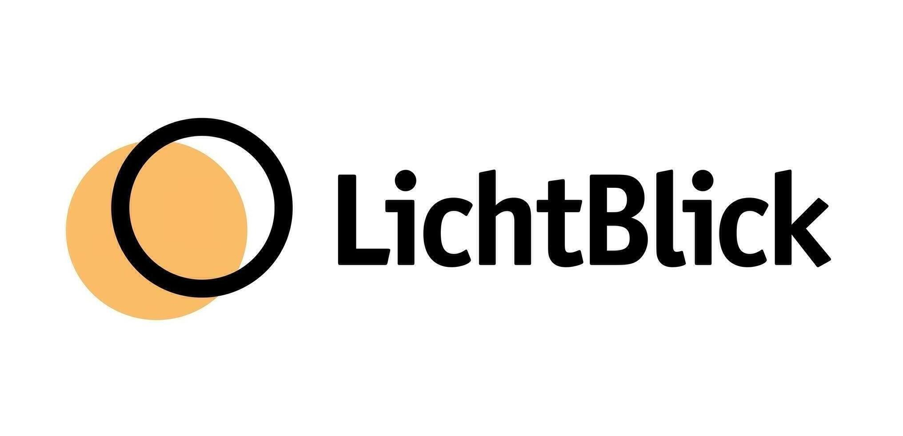
April 2021 - June 2021
Established cloud governance framework ensuring security and compliance. Implemented monitoring solution using LogAnalytics, Application Insights, and Azure Monitor. Designed microservice architecture and created automated CI/CD pipelines in Azure DevOps.
Tech Stack: | Azure, Azure DevOps, C#, Pulumi, REST

BRZ Deutschland GmbH - Cloud Architect / DevOps Engineer |  | 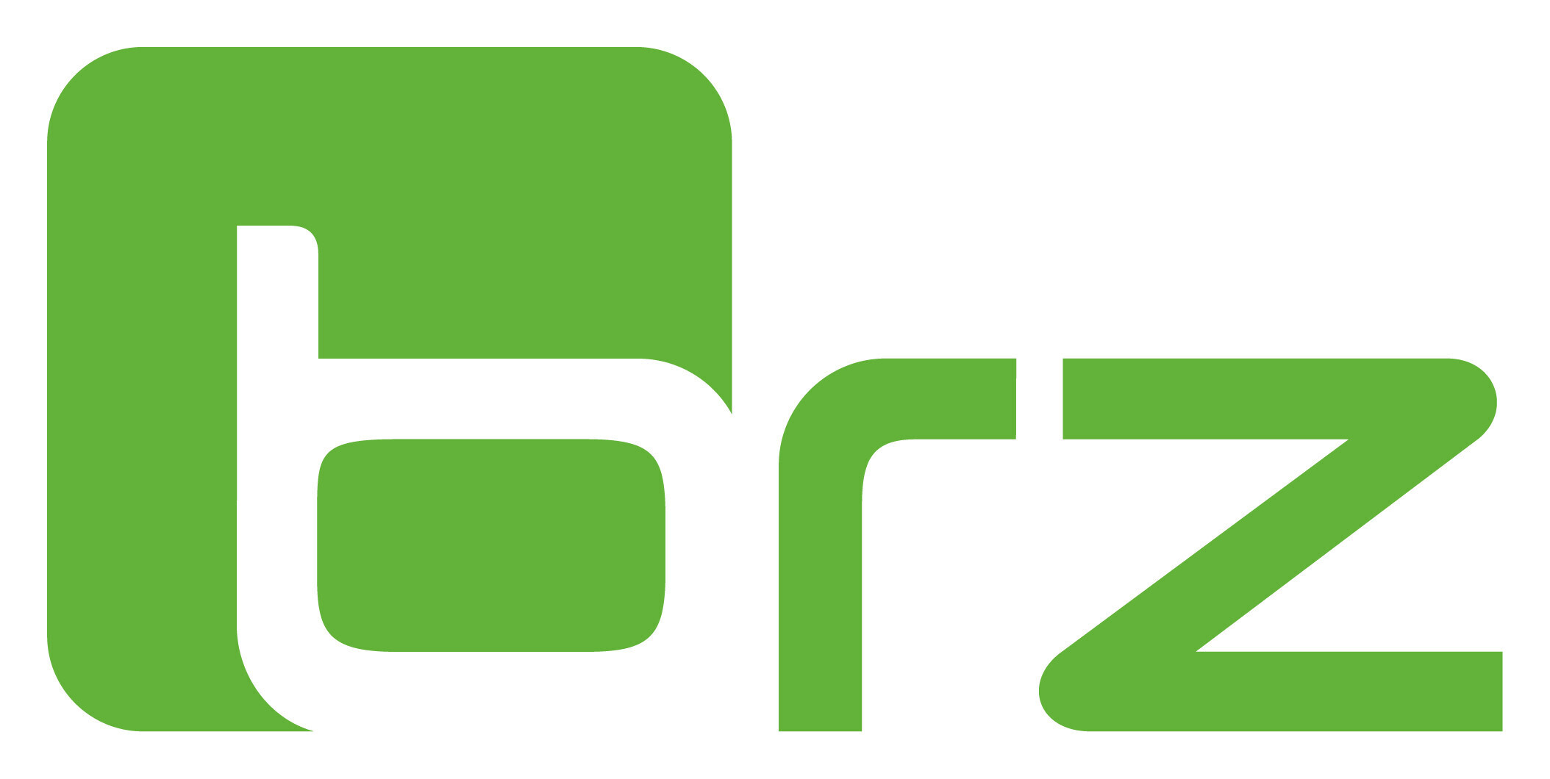
March 2020 - March 2021
Created reusable Infrastructure as Code modules with Terraform for standardised service deployment. Designed and implemented micro-service architecture enabling independent scaling. Create a well architected landing zone. Established comprehensive CI/CD pipelines in Azure DevOps for automated infrastructure and application deployments.
Tech Stack: | Azure, Azure DevOps, Terraform, C#, Docker

Siemens AG - Cloud Architect / DevOps Engineer |  | 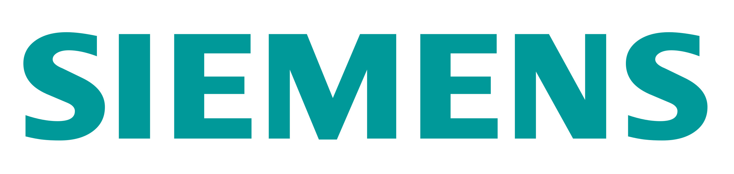
August 2019 - March 2020
Designed lift-and-shift cloud migration strategy for legacy applications. Created reusable deployment environments with Terraform. Implemented automated application deployment using Ansible. Enhanced security through modern OIDC and OAuth2 authentication.
Tech Stack: | AWS, Ansible, Terraform, Windows, OIDC, Packer, ElasticSearch, C#

EMCO-TEST Prüfmaschinen GmbH - Software Architect |  | 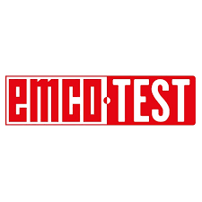
March 2018 - February 2019
Developed configuration and control software for hardness testing machines. Designed an extensible and scalable software architecture. Introduced DevOps principles into the software development process to improve delivery speed and reliability. Established continuous integration and deployment pipelines.
Tech Stack: | C#, .NET, TeamCity, Azure, AppCenter, Docker, OpenCV

PALFINGER AG - Software Developer / Architect |  | 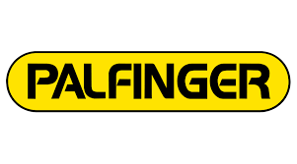
December 2011 - February 2018
Led the technical development of new diagnostic and configuration software for industrial equipment. Drove the adoption of agile development methodologies to improve team productivity and software quality. Implemented CI/CD practices for more reliable and frequent deployments. Designed and developed IoT solutions for remote monitoring and management of heavy machinery.
Tech Stack: | C#, .NET, Azure DevOps, WPF, Embedded Linux, Docker, Azure, IoT, Angular

